When Pressing Twice Makes It Worse: A Usability Breakdown of an Elevator Control Panel
Jaxon Doolittle
Georgia Southwestern State University
CSCI 6800: Human-Computer Interaction & Interface Design
Fall 2026
Assignment 1: Observing and Analyzing Bad Designs
Due: August 23, 2026
Every elevator ride is a tiny decision task dressed up as nothing at all. You form a goal (get to your floor), translate it into a single action (press a button), and trust the system to confirm it understood you. Most elevators pull this off so cleanly you never think about it twice. But watch people closely in the wrong elevator, and that trust breaks down in real time: hesitation, repeated presses, and passengers just guessing whether anything actually happened. That breakdown is the subject of this report: a single control panel that violates almost every core principle in Chapter 1 of The Design of Everyday Things, and what a redesign that actually respects those principles would look like.
1. System and Context Description
The system under review is the passenger elevator serving the parking garage and residential floors of my apartment building. It's a mixed-use structure with two below-ground parking levels (P1, P2), a ground-floor lobby (G), and six residential floors above it (1 through 6). The elevator is the only vertical access point for anyone entering from the garage, which means every resident, guest, and delivery driver who parks underground has to use it, not just residents walking in from the street.
The primary task is simple to describe and, as it turns out, not simple to execute: select the correct floor and get off there without ambiguity about whether the elevator registered the choice. The intended users span a wide range of familiarity, from residents who ride it daily and have quietly learned its quirks, to first-time guests, delivery drivers, and movers who have never seen the panel before and have no reason to expect it to behave unusually. Figure 1 shows the observed panel layout.
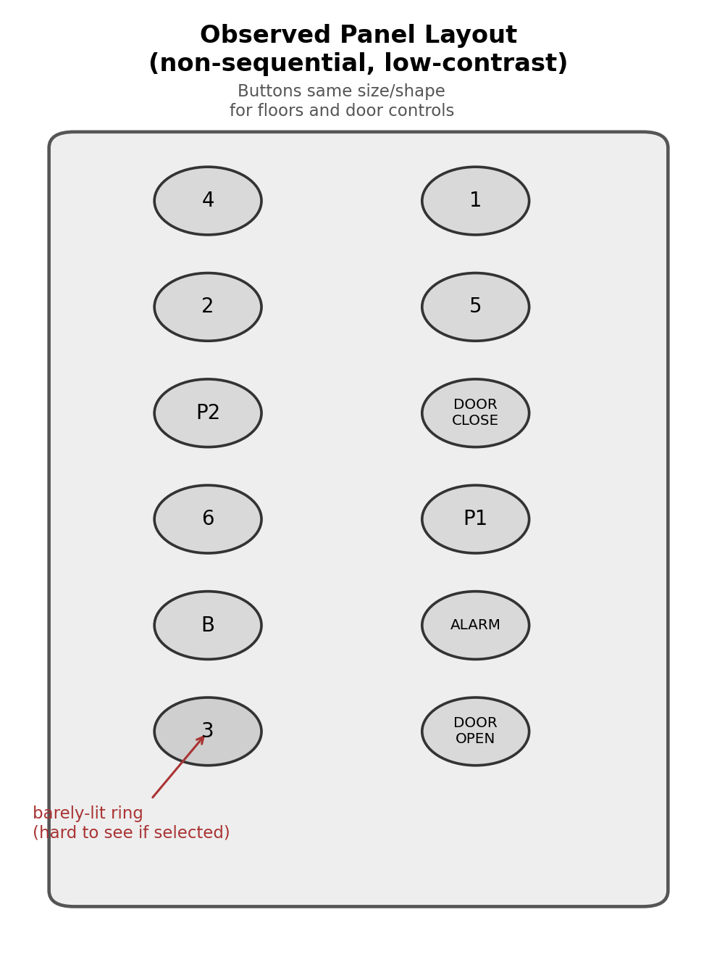
Figure 1. Observed elevator panel layout: non-sequential floor order, low-contrast selection state, identical button styling for floor and door controls.
2. Observation and Evidence
I observed the garage-level elevator lobby over two separate evenings, roughly 5:30 to 7:00 PM, a high-traffic window as residents get home from work. I stayed far enough back to watch naturally without prompting anyone or being asked what I was doing. The notes below separate what I actually saw from what I think explains it; the explanation is developed further in Section 3.
Observations
I hung around the garage-level elevator lobby over two evenings and caught somewhere around fifteen to twenty rides, though I wasn't tracking every single one closely enough to give an exact count. A good chunk of riders, more than I expected, pressed their floor button, glanced at it, and pressed it again before the doors shut. At least a few times the light seemed to go dark right after that second press, and I watched a couple of people not notice until the elevator went right past their floor, at which point one of them muttered something like “huh, that's weird” and jabbed the button again. I couldn't always tell from where I was standing whether the light actually went out or just looked that way in the lobby lighting, so I'm not fully confident on an exact count there. A woman who clearly hadn't been in the building before stood in front of the panel for a few seconds before pressing anything, looking back and forth between the buttons, and asked the resident walking her in “wait, which one is it again?” before finding it.
Nobody reacted to any sound when the doors opened, and I never heard one. Most people on their phones didn't look up until the doors were already moving, and one guy started to step out before catching himself, glancing at the number above the door mid-step. At one point someone reaching for a floor button hit “Door Close” instead, since it sits right in the same block of buttons and doesn't look any different, and had to fumble for the right one a second later while apologizing to whoever was getting on. I also overheard a resident tell someone new to the building not to double-press the buttons because “it undoes it,” which suggests this is something regulars have just learned to work around rather than something that only happened to be a problem those two nights. Not every ride had a hiccup; plenty of people got in, hit their floor once, and got off without any issue, but the pattern showed up often enough that it didn't feel like a one-off.
Interpretation
Taken together, these aren't isolated user mistakes. The same failure (press, hesitate, press again, lose the selection) showed up independently across riders who had never met each other, which is the signature of a design problem rather than a person problem. Section 3 connects each of these observations to a specific breakdown in Norman's framework.
3. HCI Analysis
The panel fails in a handful of specific, nameable ways, and each one maps directly onto the observed behavior above.
The clearest is weak affordances. Every button on this panel (floor selection, door hold, door close, alarm) is the same shape, the same size, and the same shade of gray, distinguished only by small printed text. A button's whole job is to visually announce what pressing it does, and when a floor button and a “close the doors on the person about to walk in” button look identical, the panel is offering the same affordance for two functions that should never be confused. That's exactly what happened to the rider who hit “Door Close” instead of their floor.
A second problem is broken natural mapping. The floor grid runs in two columns that don't correspond to the actual vertical order of the building: 4 sits above 2, which sits above P2, with 1, 5, and P1 scattered in the second column. A good mapping would let the panel's layout physically mirror the floors it controls, the way a stove's controls should mirror its burners. This one doesn't, which is exactly why first-time visitors had to hunt for the floor a resident had told them about; the layout gives them nothing to reason from.
The single most damaging flaw, though, is feedback that lies by omission. What happens on a second press is that the light goes out, silently canceling the selection, with no distinct “this just got un-selected” signal separate from the normal unlit state. Good feedback tells the user what just happened. This panel tells the user nothing happened, which is worse than telling them the wrong thing, because it looks identical to the button simply never having registered in the first place.
That points to the real root cause: a user model that doesn't match the design model, a conceptual model mismatch in Norman's exact sense. The rider's mental model, reasonably, is “if I'm not sure it worked, pressing it again can only help.” The system's actual model is “a second press on a lit button toggles it off.” Nothing in the panel communicates that second model to the user, so the user acts on the wrong one, and the elevator, correctly following its own logic, punishes them for it.
None of this is helped by a total absence of constraints against the obvious failure mode. Norman's point about constraints is that good design uses them to make the wrong action harder or impossible. Nothing here stops a second press on an already-lit button from doing anything at all; a single logical constraint, ignoring repeated presses on a selected floor, would have prevented the entire failure pattern observed above.
Walking one of these rides through Norman's seven stages of action shows exactly where the breakdown lands. The rider forms the goal (reach floor 3), forms the intent (press the button labeled 3), and specifies and executes the action (locates it in the cluttered grid, presses it). From there it falls apart: perceiving the state of the world (the dim ring around the button) gives almost no usable signal in a brightly lit lobby, so evaluating the outcome (did that register?) and interpreting the state of the world (I guess not, better press again) both happen on bad information. That's the gulf of evaluation Norman describes: the execution side went fine, but the system gave the rider nothing reliable to evaluate, so their next action, driven by reasonable uncertainty, undid the first one.
It's also worth naming what kind of error this is, because the fix depends on it. This is a slip, not a mistake: the rider's goal and intent were both correct the entire time, and a more familiar habit (press again to be sure, the same instinct that drives a double-click) took over during execution. Norman's advice for slips is specific: make errors easy to detect and correct, and design for approximate behavior instead of treating it as user failure. This panel does neither. It doesn't help the rider notice the error, and it doesn't tolerate the very natural behavior of double-checking.
This is a familiar problem from the software side too. Building interfaces for Shrood's AI tools taught me the same lesson the hard way: the fastest way to lose a user's trust isn't a slow system, it's a system that gives an action no visible outcome at all. A user who can't tell whether their click registered will click again, and if that second click does something destructive instead of nothing, the interface has manufactured its own error. An elevator button and a submit button are the same design problem wearing different housings.
4. Redesign Recommendation
The fix doesn't require new technology, just applying the principles the current panel ignores. Figure 2 shows the proposed layout.
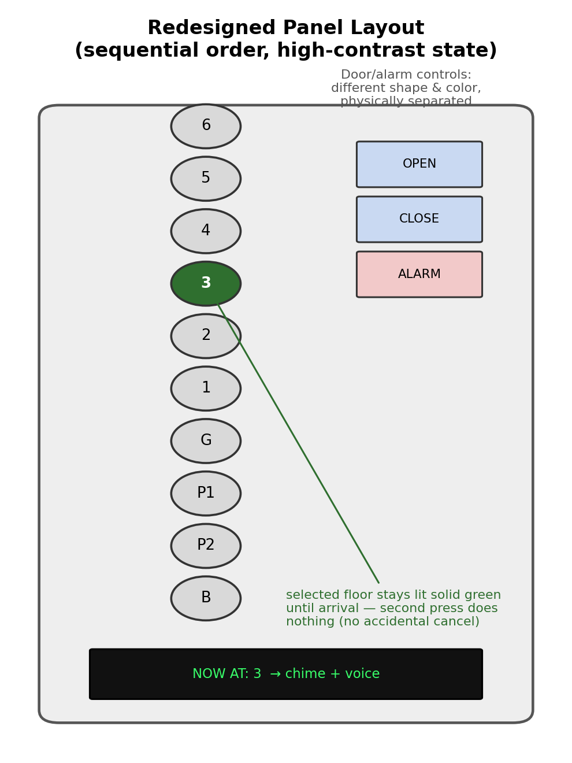
Figure 2. Redesigned panel: sequential floor mapping, a persistent high-contrast selected state, and door/alarm controls separated by shape and color.
The first change is sequential mapping: arrange the floor buttons in a single column running top to bottom in the same order as the building itself, 6 through 1, then G, then P1 and P2, then B. A rider no longer has to search a grid; the layout already tells them where to look. The second is a real “selected” state, protected by a constraint: once pressed, a floor button lights up solid and high-contrast instead of a faint ring, and stays that way until the elevator arrives. A second press on an already-selected button does nothing, closing off the exact failure mode observed repeatedly above.
Third, door and alarm controls should be differentiated from floor buttons: door open, door close, and alarm move to a separate section of the panel, in a different shape and color, so they can't be mistaken for a floor selection by someone who isn't looking directly at the panel. Fourth, feedback shouldn't require the rider to look for it at all: an audible chime plus a spoken floor announcement on arrival, alongside a larger, higher-contrast arrival display, closes the gulf of evaluation directly by giving confirmation through two channels instead of one small, easily missed light.
None of this requires a smarter elevator, just one that tells the truth about its own state and gets out of the way of a reasonable, predictable human action.
5. Evaluation Plan
Two measures would tell me directly whether this redesign actually works, and a third would round it out.
The first is error rate, accidental cancellations per ride, defined as the percentage of rides in which a rider presses an already-lit floor button and deselects it, observable the same way I tallied it above (a light going dark after a repeated press, or a rider re-pressing near their floor). Going off what I watched, that was happening on a meaningful chunk of rides, easily a quarter or more; since the redesign makes a second press a no-op, I'd expect this to drop close to zero. The second is floor-selection time, measured from the moment a rider's finger first reaches toward the panel to the moment their selection is confirmed and uncontested (no further presses on that button). A formal baseline would need a stopwatch rather than my rough field notes, but the hesitate-and-repress pattern clearly added a few extra seconds each time it happened, and a single confident press should bring that down close to a single beat.
A third, optional measure is rider confidence: a short one-question, five-point scale asked as people exit (“How confident were you that your floor selection registered correctly?”), sampled across a comparable number of rides before and after. I'd expect the average to move from around 3 out of 5 (uncertain, several riders openly said as much) to 4.5 or higher once the feedback is unambiguous.
I'd collect all three with the same unobtrusive observation approach used for this report, at matched times of day and traffic volume before and after the panel change, so the comparison isn't confounded by rush-hour versus off-peak behavior.
Norman's mantra from Chapter 1 is blunt: if a simple thing requires instructions, it's a failed design. This panel requires exactly that; the workaround (“don't press it twice”) only survives at all because residents pass it on to guests by word of mouth. A design that needed nobody to explain it wouldn't need that folklore in the first place.

